Task on Ec2

- Launch one EC2 using Amazon Linux 2 image and add a script in user data to install Apache.
Go to ec2 dashboard
AMI : amazon linux 2
instance type : t2.micro
select key pair
Network : default VPC / any subnet
To add a script in user data to install apache httpd ---- go to User data
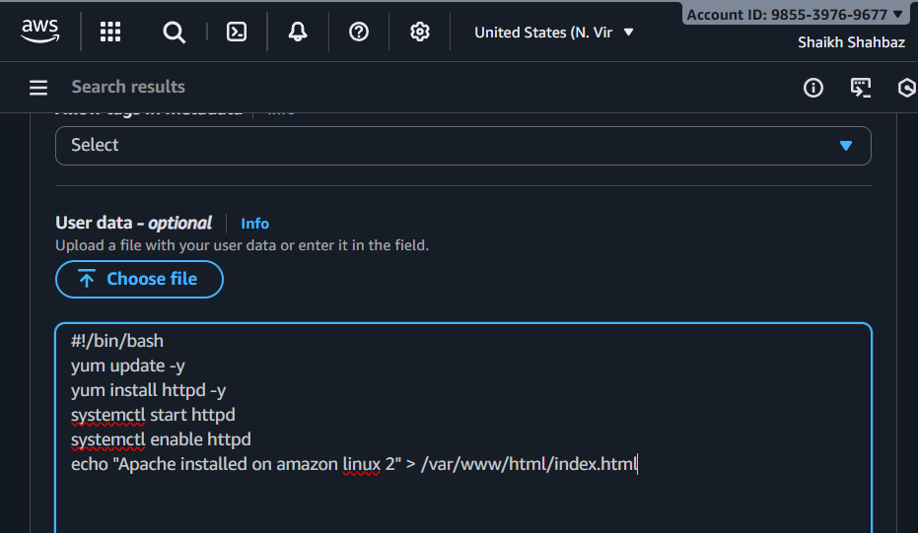
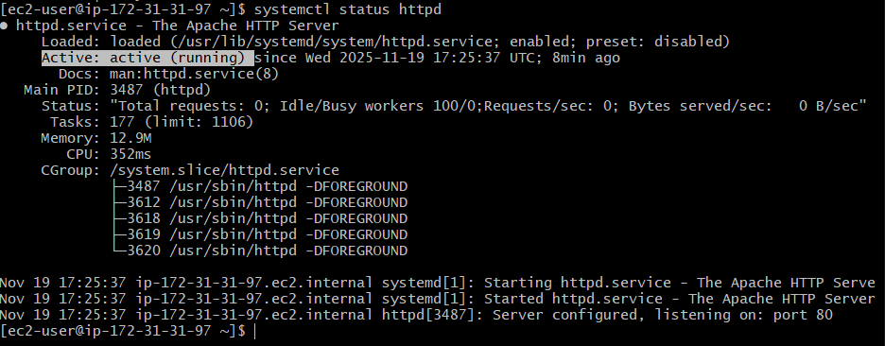

- Launch one EC2 using Ubuntu image and add a script in user data to install Nginx.
Go to ec2 dashboard
AMI : Ubuntu server 22.04
Instance type : t2.mircro
Under User Data :
Edit inbound rules :
Type : ssh port : 22 source : 0.0.0.0/0
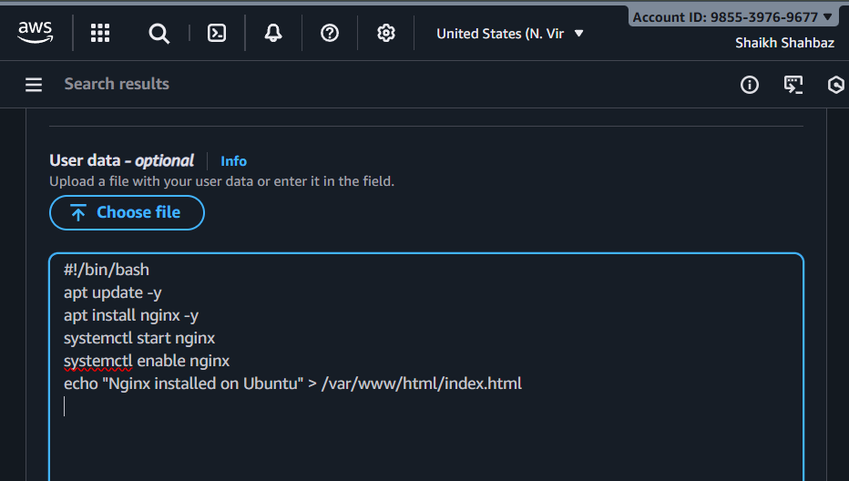
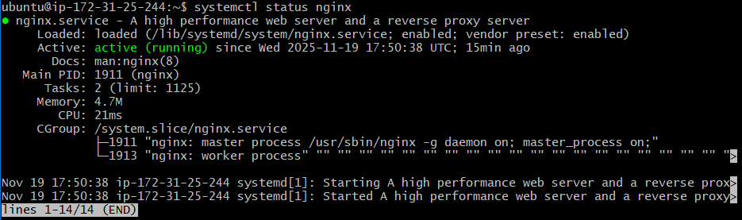

- Launch one Windows server and install Tomcat on Windows.
Go to ec2 dashboard
AMI : choose windows server 2025
Select instance type : t3.micro
Complete launch
After instance is running – RDP into machine
we need to install tomcat manually
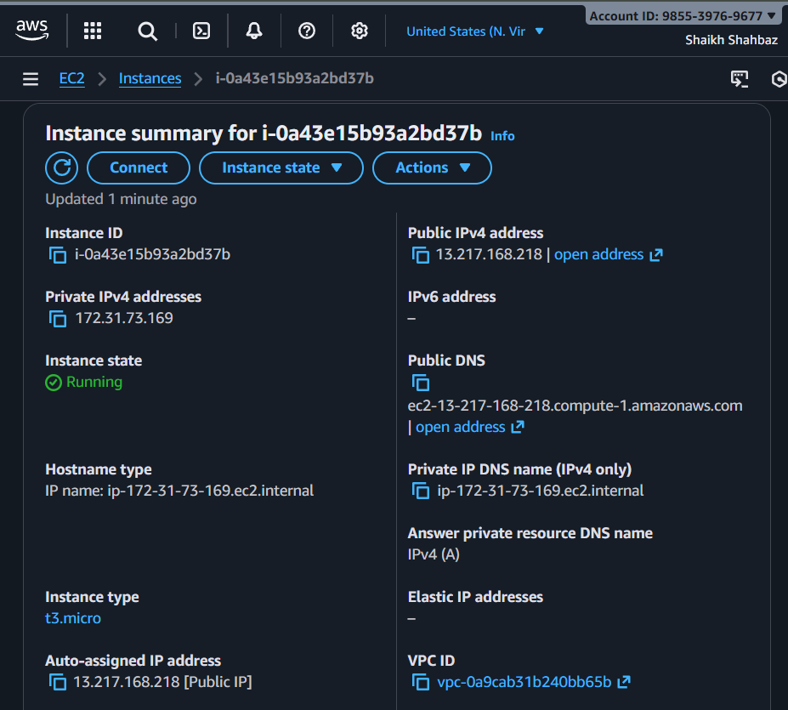
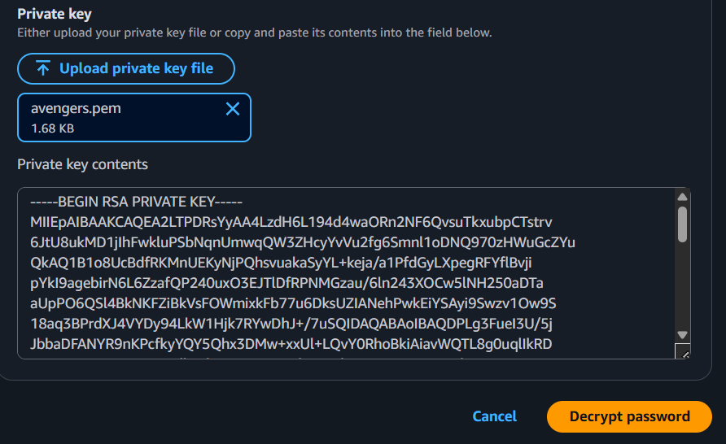
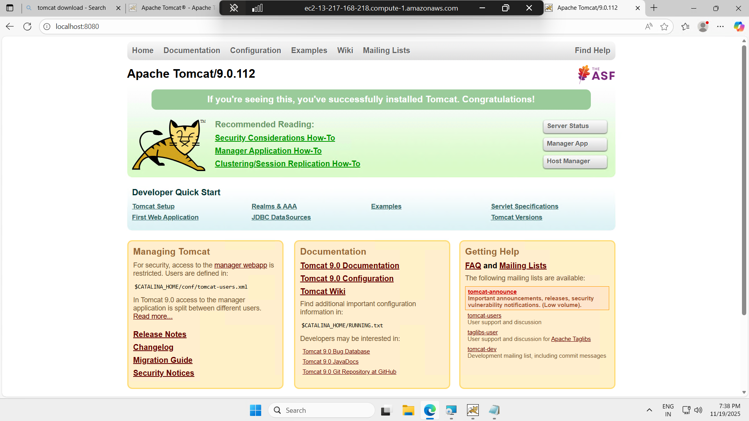

- Take a snapshot of the instance created in Task 1.
Open Ec2 instance
Select amazon linux instance
Scroll StorageRoot Volume ID
Click the Volume ID
ActionsCreate Snapshot
Give descriptionCreate snapshot
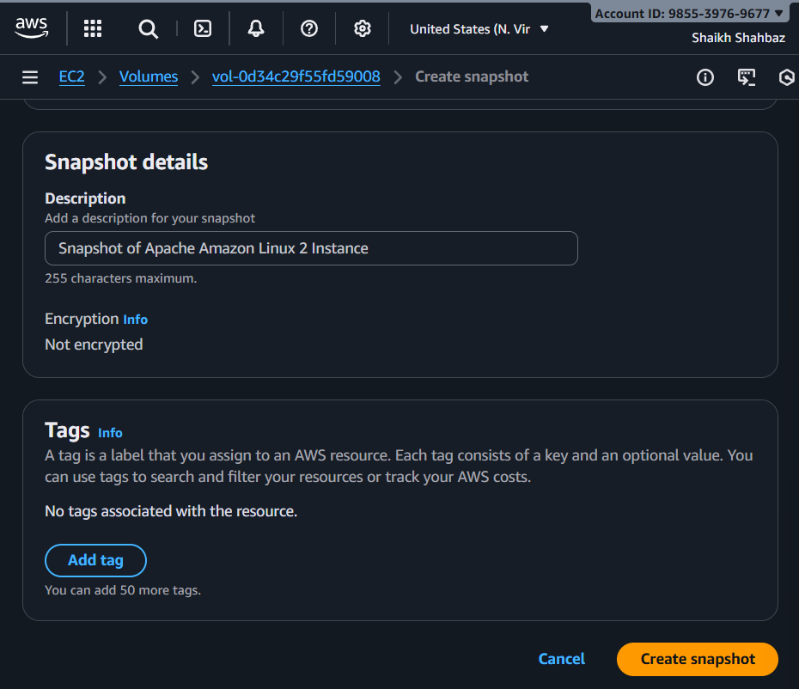
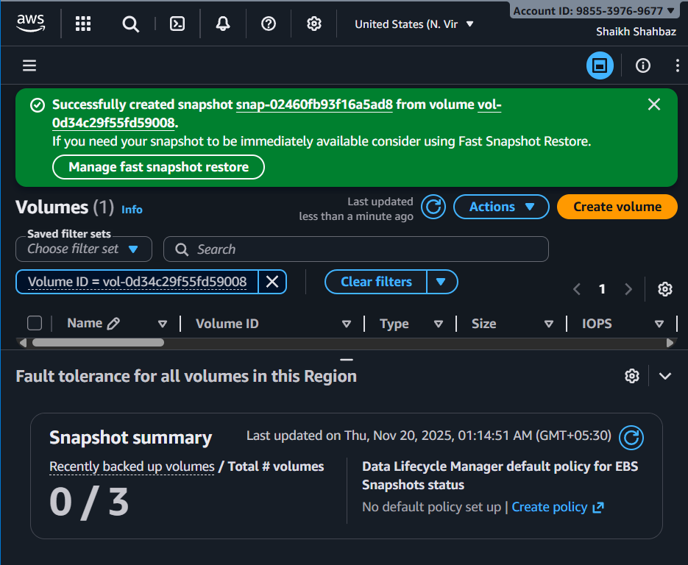

- Assign passwordless authentication for the EC2 created in Task 2.
Generate key pair
Ssh-keygen
Copy the public key to server
Now login ubuntu@<ec2-public-ip>

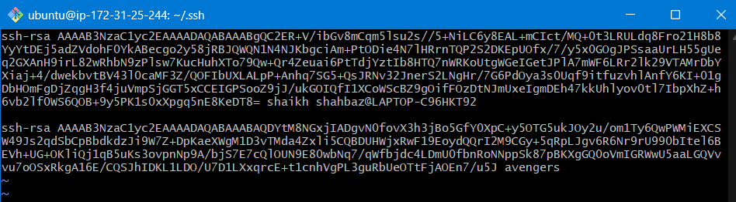
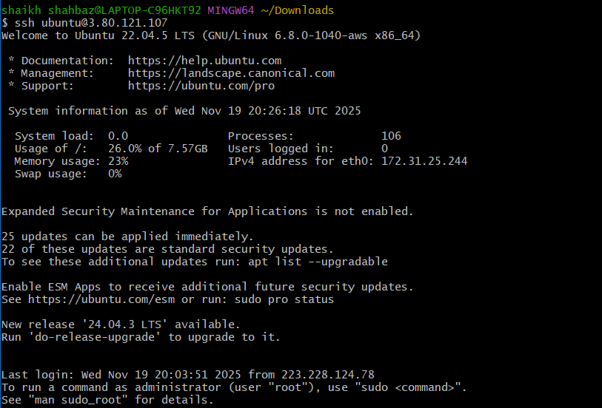

6. Launch any EC2 using the spot purchasing option.
Launch Instance
Under Instance Type, click Request Spot Instance
Choose :
*Instance Type
*Mximum Price (optional)
Continue and launch instance
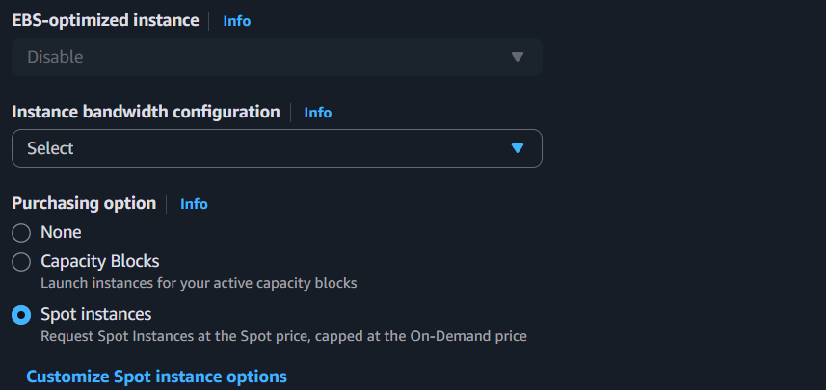
7. Enable termination policy on the EC2 created in Task 2.
Goto ec2 instances
Select Ubuntu instance
ActionsInstance Settings
Click Change Termination Protection
Enable it

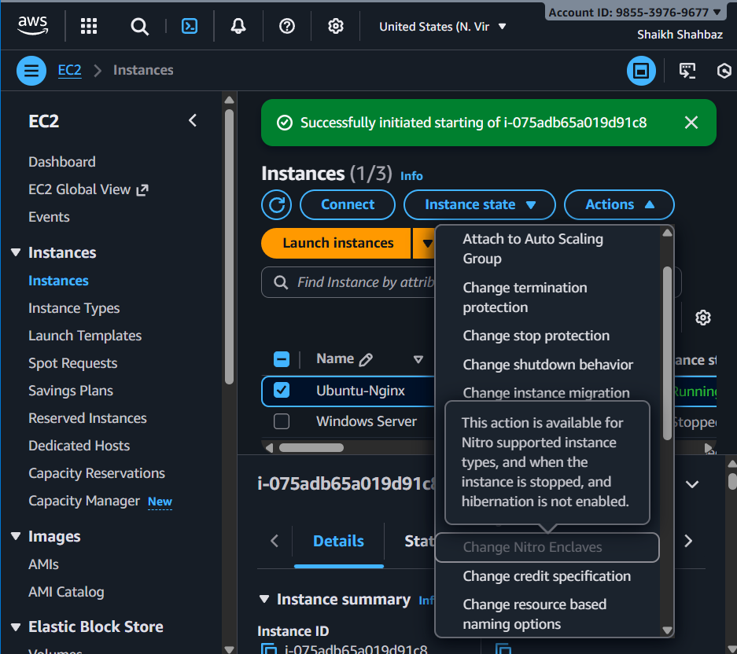
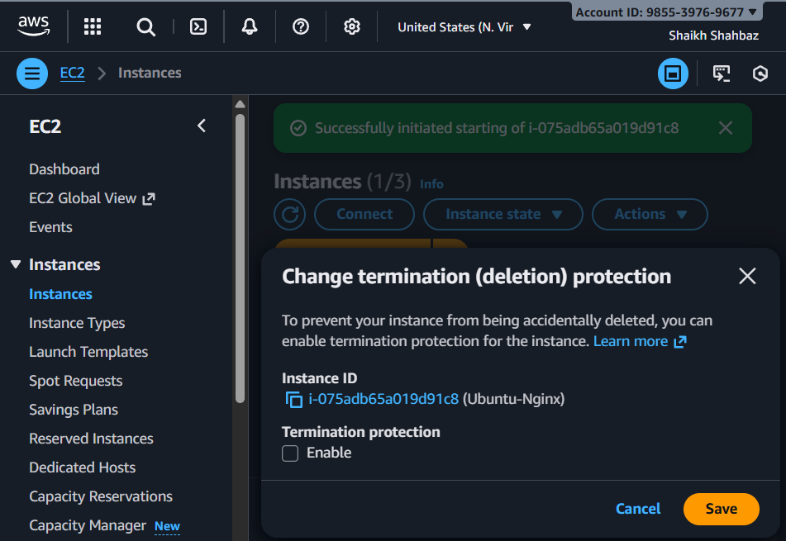

8.Launch one EC2 using AWS CLI.
aws ec2 run-instances \
--image-id ami-0c398cb65a93047f2 \
--instance-type t2.micro \
--key-name avengers \
--security-group-ids sg-0487a7df9bff4635b \
--subnet-id subnet-0074ceb1237d4ec79
After it launches the public ip with :
aws ec2 describe-instances --query "Reservations[].Instances[].PublicIpAddress" --output table

